# W1

## Initialization

* Different initializations lead to different results
* Random initialization is used to break symmetry and make sure different hidden units can learn different things
* Don't initialize to values that are too large
* He initialization works well for networks with ReLU activations.

### Zero initialization



### Random initialization



### He initialization



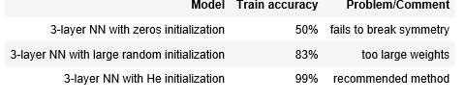

## Train / Dev / Test sets

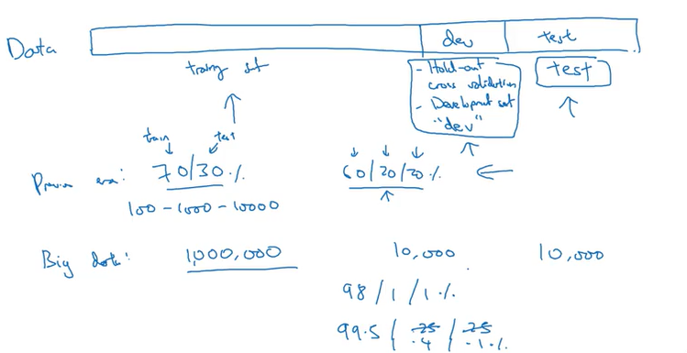

* One other trend we're seeing in the era of modern deep learning is that more and more people train on mismatched train and test distributions.
* The dev and test set should come from the same distribution

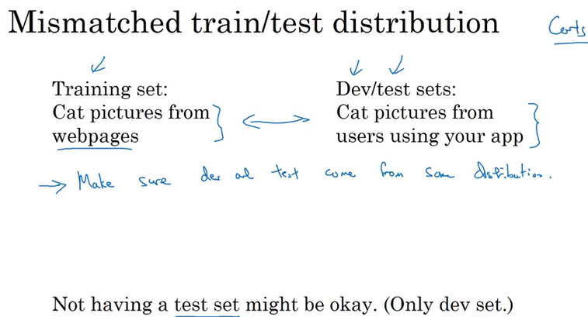

* when setting up your machine learning problem, I'll often set it up into a train, dev and test sets,
* if you have a relatively small dataset, these traditional ratios might be okay.(60/20/20)
* But if you have a much larger data set, it's also fine to set your dev and test sets to be much smaller than your 20% or even 10% of your data.
* When you have just a train and a dev set but no separate test set.
  + Most people will call this a training set and they will call the dev set the test set. But what they actually end up doing is using the test set as a hold-out cross validation set.
  + Which maybe isn't completely a great use of terminology, because they're then overfitting to the test set.
* So when the team tells you that they have only a train and a test set, I would just be cautious and think, do they really have a train dev set? Because they're overfitting to the test set.
* So having set up a train dev and test set will allow you to integrate more quickly. It will also allow you to more efficiently measure the bias and variance of your algorithm so you can more efficiently select ways to improve your algorithm.

## Bias-underfitting/Variance-overfitting

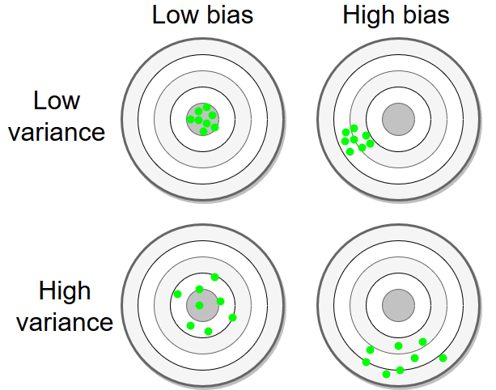

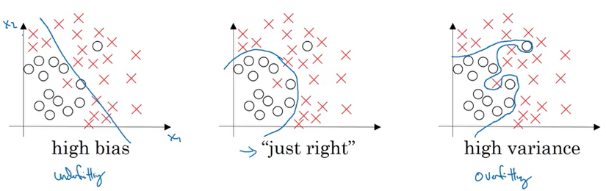

High variance:

* Fits well with training data but not test data.

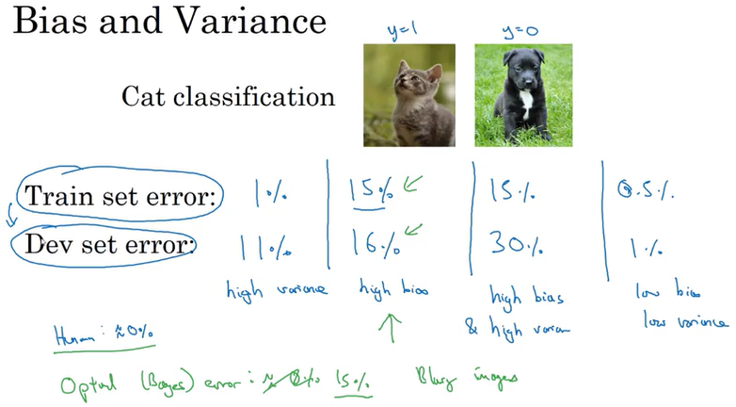

## Basic Recipe for ML

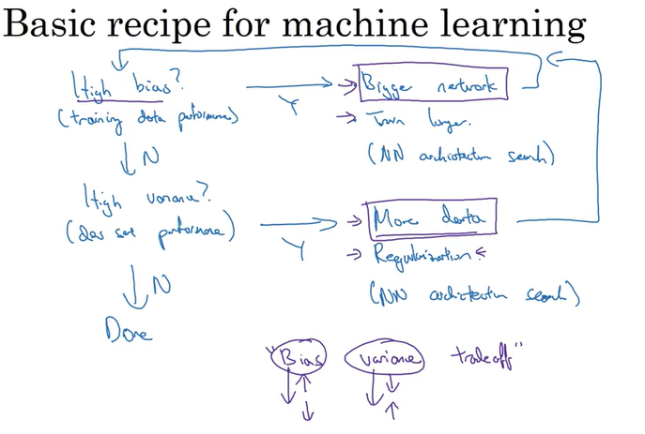

* Use the training dev set to try to diagnose if you have a bias or variance problem, and then use that to select the appropriate subset of things to try.
* Regularization, is a very useful technique for reducing variance. There is a little bit of a bias variance tradeoff when you use regularization. It might increase the bias a little bit, although often not too much if you have a huge enough network

## To prevent High variance (overfit)

* + Try smaller set of features
  + Dropout
  + L2 regularization
  + Data augmentation
  + Increase lambda
  + Get more training data

## To prevent high bias (underfit)

* + Make the neural network deeper
  + Decrease lambda

## Regularization

Prevent overfitting

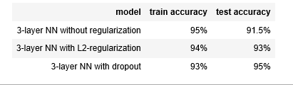

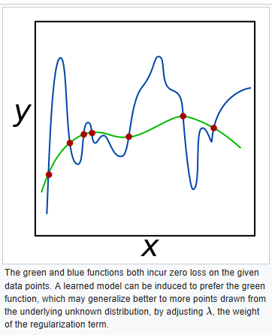

### Log.Reg. Regularization

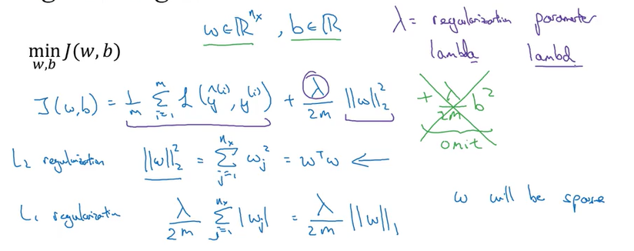

* Cost function is some of your training examples of the losses of the individual predictions in the different examples, where you recall that w and b in the logistic regression, are the parameters.
* Why do you regularize just the parameter w? Why don't we add something here about b as well?
* W is usually a pretty high dimensional parameter vector, especially with a high variance problem. Maybe W has a lot of parameters, so you aren't fitting all the parameters well, whereas b is just a single number.

### NN Regularization

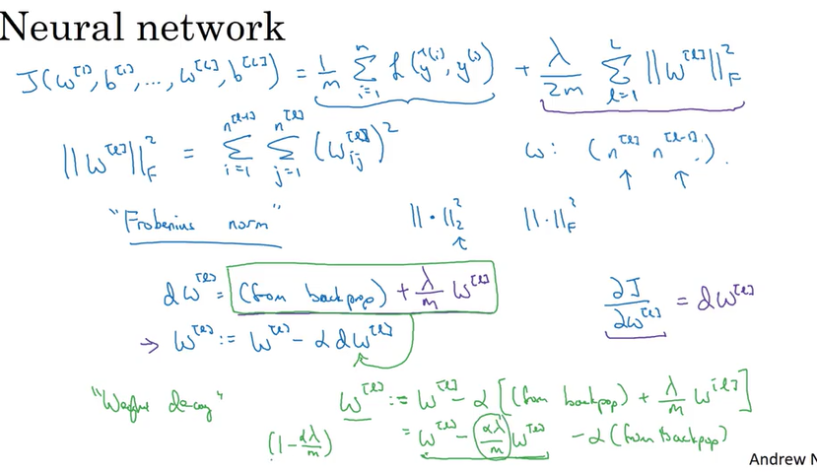

#### Weight decay

* A regularization technique (such as L2 regularization) that results in gradient descent shrinking the weights on every iteration.
* L2 norm regularization

### Why regularization reduces overfitting?

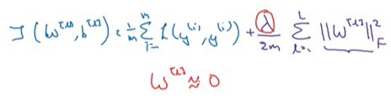

* Why is it that shrinking the L two norm or the Frobenius norm or the parameters might cause less overfitting?
  + If you crank regularization lambda to be really, really big, they'll be really incentivized to set the weight matrices W to be reasonably close to zero.
  + So one piece of intuition is maybe it set the weight to be so close to zero for a lot of hidden units that's basically zeroing out a lot of the impact of these hidden units. And if that's the case, then this much simplified neural network becomes a much smaller neural network.

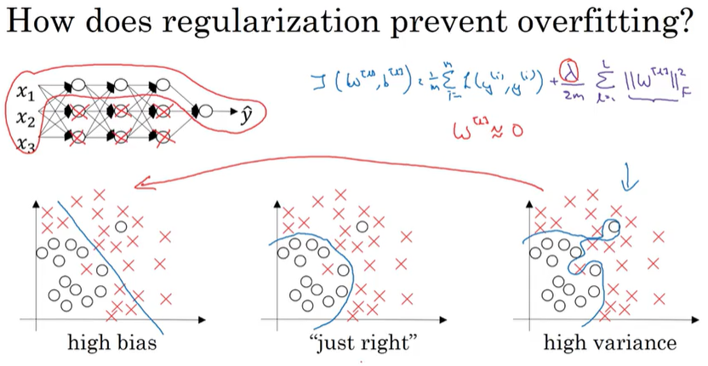

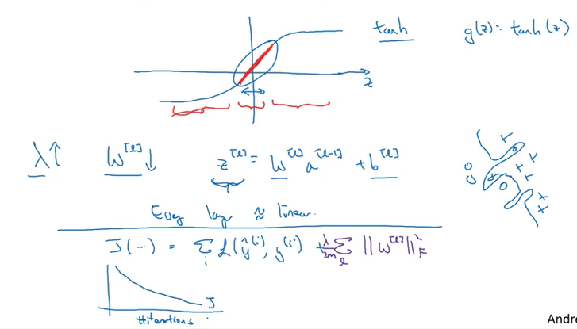

## L1 regularization

A type of regularization that penalizes weights in proportion to the sum of the absolute values of the weights. In models relying on sparse features, L1 regularization helps drive the weights of irrelevant or barely relevant features to exactly 0, **which removes those features from the model**. Contrast with L2 regularization.

## L2 regularization - weight decay

* A type of regularization that penalizes weights in proportion to the sum of the squares of the weights. L2 regularization helps drive outlier weights (**those with high positive or low negative values) closer to 0** but not quite to 0. (Contrast with L1 regularization.) L2 regularization always improves generalization in linear models.
* The main idea of L2 regularization is to reduce the magnitude of weights to reduce overfitting. Adding this term ensures that our cost function does not solely emphasise on fitting the training data but also keeping the weights low.
* Therefore, larger weight values will contribute to larger error, and so smaller weights will be rewarded.

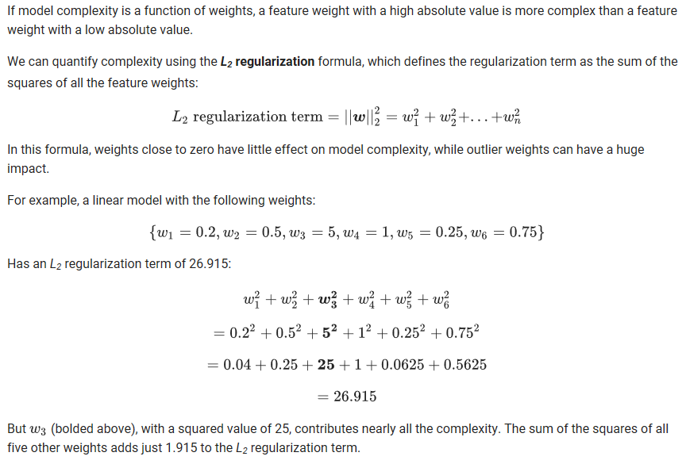

W3

## Dropout Regularization

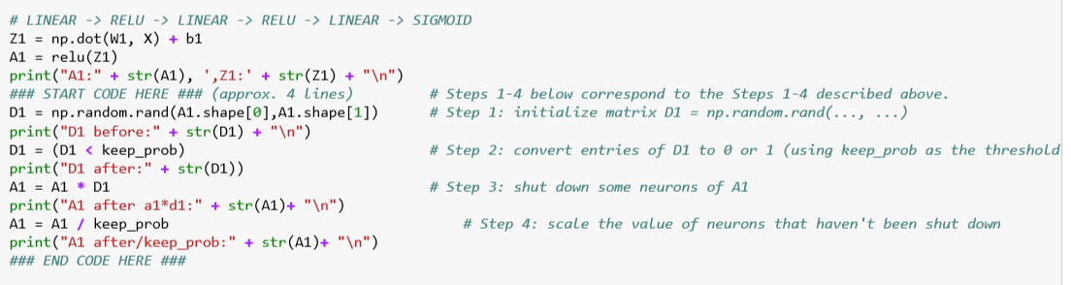

* Let's say you train a neural network like the one on the left and there's over-fitting

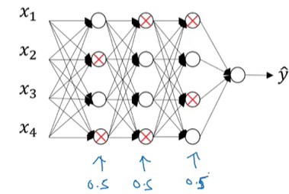 -> 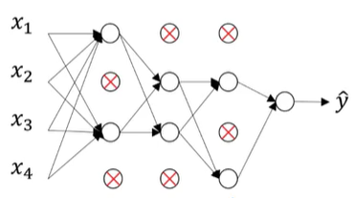

* With dropout, we will go through each of the layers of the network and set some probability of eliminating a node in neural network.(0.5 chance of removing and 0.5 not removing

### Inverted dropout

* Inverted dropout is a variant of the original dropout technique developed by Hinton et al.
* Just like traditional dropout, inverted dropout randomly keeps some weights and sets others to zero. This is known as the “keep probability” p
* The one difference is that, during the training of a neural network, inverted dropout scales the activations by the inverse of the keep probability q=1−p
* This prevents network’s activations from getting too large, and does not require any changes to the network during evaluation.
* In contrast, traditional dropout requires scaling to be implemented during the test phase.
* You do not apply dropout (do not randomly eliminate units) during test phase and do not keep the 1/keep_prob factor in the calculations used in training

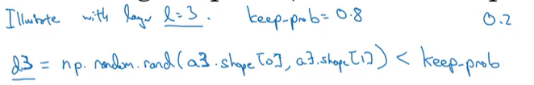

* The random numbers above have 0.8 chance of being 1.; 02 as 0

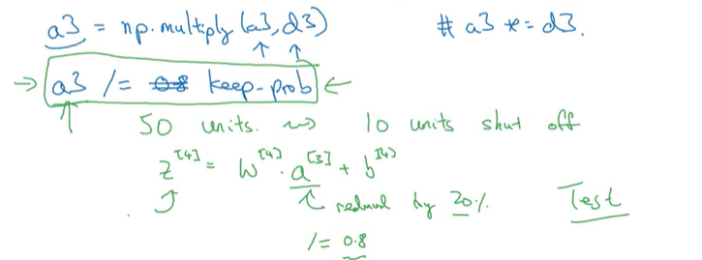

* Maybe a3 is 50 by one dimensional or if you- factorization maybe it's 50 by m dimensional. So, if you have 80% chance of keeping them and 20% chance of eliminating them.
* 20% of the elements of a3 will be zeroed out.
* It ensures that the expected value of a3 remains the same.
* This makes test time easier because you have less of a scaling problem.

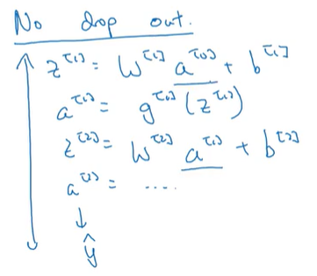

* Dropout is not used in test time; you're not tossing coins at random, you're not flipping coins to decide which hidden units to eliminate; because when you are making predictions at the test time, you don't really want your output to be random.
* If you are implementing dropout at test time, that just add noise to your predictions. In theory, one thing you could do is run a prediction process many times with different hidden units randomly dropped out and have it across them. But that's computationally inefficient and will give you roughly the same result;

## Dropout

* A form of regularization useful in training neural networks. Dropout regularization works by removing a random selection of a fixed number of the units in a network layer for a single gradient step. **The more units dropped out, the stronger the regularization**. This is analogous to training the network to emulate an exponentially large ensemble of smaller networks
* The core idea behind dropout is to randomly set some of the weights in a neural network

to 0 during the training phase.

* Drop out is a regularization technique, it helps prevent over-fitting.
* In each iteration different neuron is dropped out below.

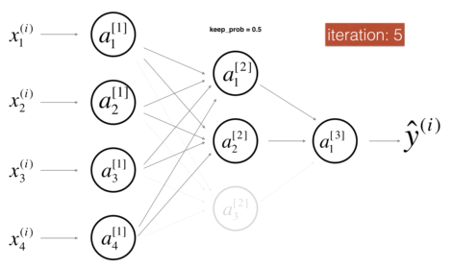 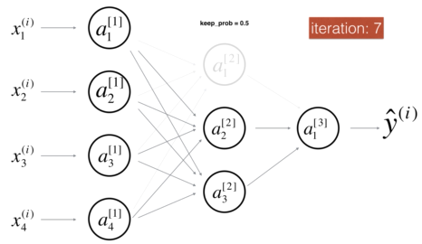 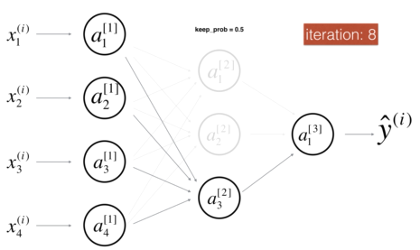

* The dropped neurons don't contribute to the training in both the forward and backward propagations of the iteration.
* The idea behind drop-out is that at each iteration, you train a different model that uses only a subset of your neurons. With dropout, your neurons thus become less sensitive to the activation of one other specific neuron, because that other neuron might be shut down at any time.

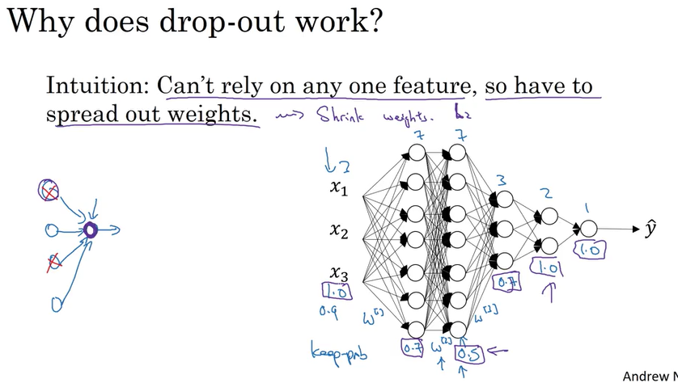

* In the little NN (left in pic) Cant rely on any one feature, so have to spread out weights; so this will tend to have an effect of shrinking the squared norm of the weights.
* In the right NN in pic w1 7x3, w2 7x7, w3 3x7 -> keep prob lower for w2.
* Keep prob=1 means all units will be kept on that layer
* If you're more worried about some layers overfitting than others, you can set a lower key prop for some layers than others.
* The downside is, this gives you even more hyper parameters to search for using cross-validation. One other alternative might be to have some layers where you apply drop out and some layers where you don't apply drop out and then just have one hyper parameter,
* The effect of implementing drop out is that it shrinks the weights and does some of those outer regularization that helps prevent over-fitting
* steps

1. So what I usually do is turn off drop out, you will set key prop equals one, and I run my code and make sure that it is monotonically decreasing J,
2. And then turn on drop out and hope that I didn't introduce bugs into my code during drop out

## Other regularization methods

### Data Augmentation (çoğaltma)

* If you are over fitting getting more training data can help, but getting more training data can be expensive and sometimes you just can't get more data.

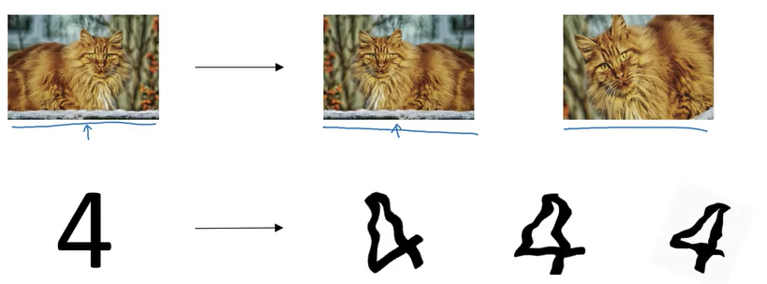

### Early stopping

A method for regularization that involves ending model training before training loss finishes decreasing. In early stopping, you end model training when the loss on a validation data set starts to increase, that is, when generalization performance worsens.

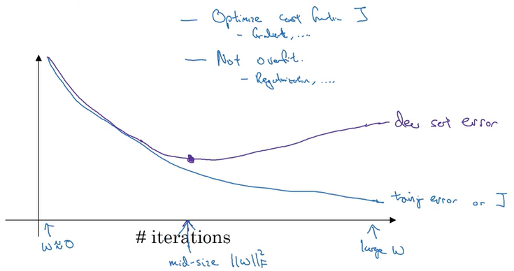

* And the advantage of early stopping is that running the gradient descent process just once, you get to try out values of small w, mid-size w, and large w, without needing to try a lot of values of the L2 regularization hyperparameter lambda.
* I personally prefer to just use L2 regularization and try different values of lambda; then you can just train the neural network as long as possible. I find that this makes the search space of hyper parameters easier to decompose, and easier to search over.

## Normalizing inputs

* When training a neural network, one of the techniques that will speed up your training is if you normalize your inputs.
* **The first step:**
  + is to subtract out or to zero out the mean.

**Before(1)** **After(2)**

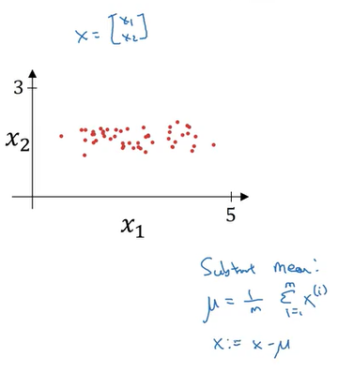 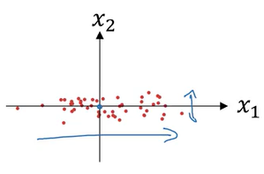

* + So this is a vector, and then X gets set as X- mu for every training example, so this means you just move the training set until it has 0 mean.
* **The second step** 
  + is to normalize variance
  + x1’s variance is much larger than x2 above in 2.nd shape above; our aim is to normalize that between x1 and x2.

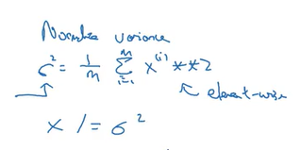

**Finally becomes(3)**

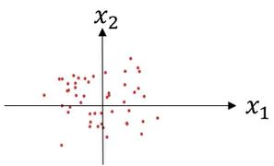

* + And one tip, if you use this to scale your training data, then use the same mu and sigma squared to normalize your test set
  + In particular, you don't want to normalize the training set and the test set differently.

## Why normalize?

* It makes the cost function faster to optimize
* If your features are on very different scales,
  + say the feature X1 ranges from 1 to 1,000,
  + and the feature X2 ranges from 0 to 1,
  + then it turns out that the ratio or the range of values for the parameters w1 and w2 will end up taking on very different values then your cost function can be a very elongated bowl like that.

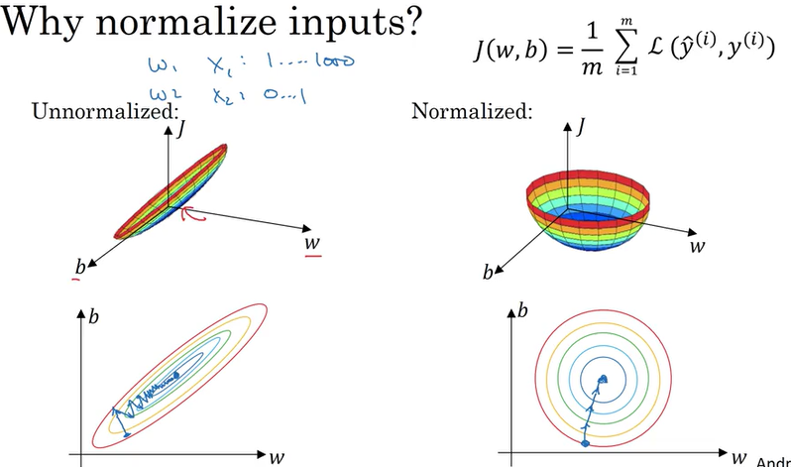

* On the left, then you might have to use a very small learning rate because if you're here that gradient descent might need a lot of steps to oscillate back and forth before it finally finds its way to the minimum.
* Whereas if you have a more spherical contours(on the right), then wherever you start gradient descent can pretty much go straight to the minimum
* Of course in practice w is a high-dimensional vector, and so trying to plot this in 2D doesn't convey all the intuitions correctly.

## Vanishing/Exploiting Gradients

* One of the problems of training neural network, especially very deep neural networks is data vanishing and exploding gradients.
* What that means is that when you're training a very deep network your derivatives or your slopes can sometimes get either very, very big or very, very small, maybe even exponentially small,
* and this makes training difficult.

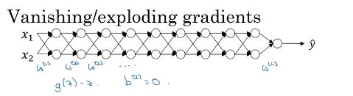

* G(z)=z a linear activation function it has

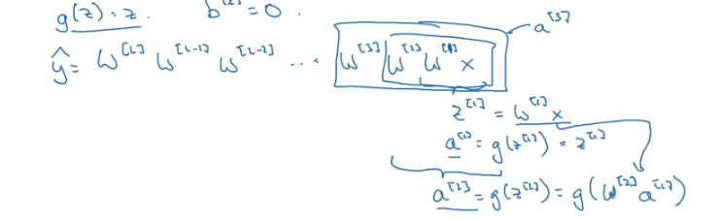

* Assume that each w matrix above has the same values below

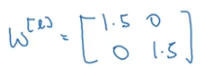

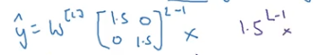

* If L was large for very deep neural network, Y-hat will be very large.

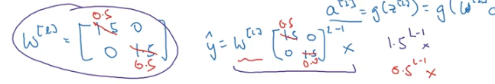

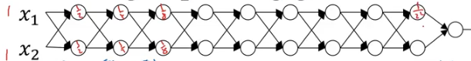

* if we replace this with 0.5,so something less than 1,then this becomes 0.5 to the power of L.

This matrix becomes 0.5 to the L minus one times X, again ignoring WL.

* And so each of your matrices are less than 1, then let's say X1, X2 were one one,
* then the activations will be one half, one half, one fourth, one fourth, one eighth, one eighth,

and so on until this becomes one over two to the L. (şekilde activation içindeyazılı ) **So the activation values will decrease exponentially as a function of the def,**

**Intuition**

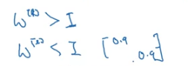

* At the weights W, if they're all just a little bit bigger than one or just a little bit bigger than the identity matrix, then with a very deep network the activations can explode. And if W is just a little bit less than identity. So this maybe here's 0.9, 0.9, then you have a very deep network, the activations will decrease exponentially
* With some of the modern neural networks, L equals 150. Microsoft recently got great results with 152 layer neural network.
* But with such a deep neural network, if your activations or gradients increase or decrease exponentially as a function of L, then these values could get really big or really small
* And this makes training difficult, especially if your gradients are exponentially smaller than L,

Then gradient descent will take tiny little steps.

## Weight Initialization for Deep Networks

* Very deep neural networks can have the problems of vanishing and exploding gradients. It turns out that a partial solution to this, doesn't solve it entirely but helps a lot, is better or more careful choice of the random initialization for your neural network.

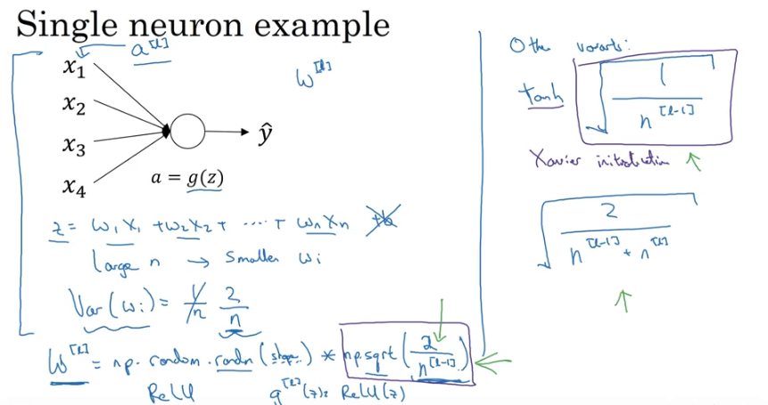

* If you have a larger n(params) then you want your Wi’s to be small in order to prevent z to explode
* One reasonable thing to do would be to set the variance of Wi to be equal to 1 over n, where n is the number of input features that's going into a neuron.

## Numerical approximation of gradients

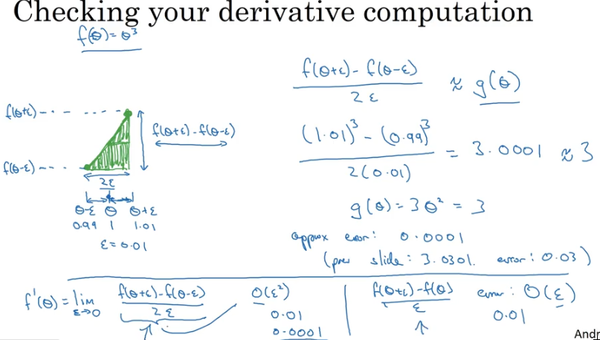

## Gradient Checking

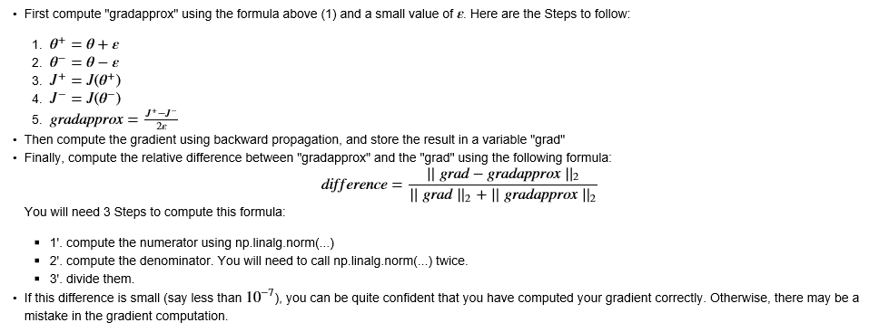

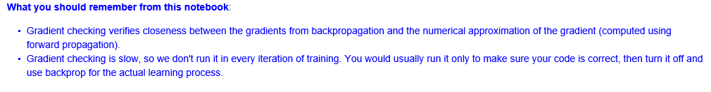

* To implement gradient checking, the first thing you should do is take all your parameters and **reshape them into a giant vector data.** So what you should do is take W which is a matrix, and reshape it into a vector theta++++++++++++++++
* You would now have the cost function J being just a function of theta.

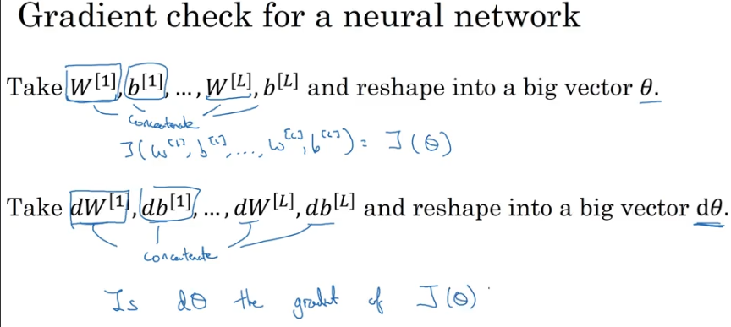

* Next, with W and B ordered the same way, you can also take dW[1], db[1] and so on, and initiate them into big, giant vector d theta of the same dimension as theta.

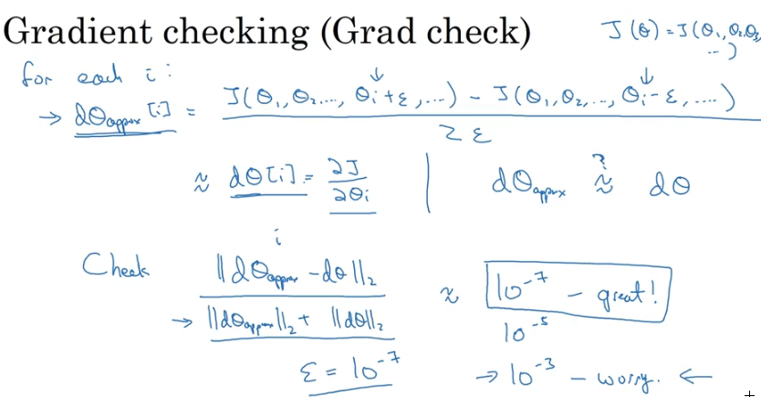

Eucledian distance

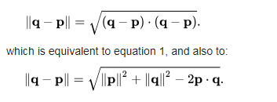

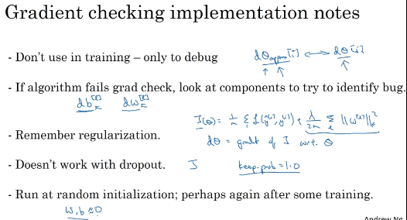

* First, don't use grad check in training, only to debug. So what I mean is that, computing d theta approx. i, for all the values of i, this is a very slow computation
* So to implement gradient descent, you'd use back prop to compute d theta and just use back prop to compute the derivative. And it's only when you're debugging that you would compute this to make sure it's close to d theta. But once you've done that, then you would turn off the grad check, and don't run this during every iteration of gradient descent, because that's just much too slow

# W2

## Mini-batch gradient descent

* With batch gradient descent on every iteration you go through the entire training set and you'd expect the cost to go down on every single iteration.
* Mini-batch gradient descent in contrast, refers to algorithm which you process is single mini batch XT, YT at the same time rather than processing your entire training set XY the same time. 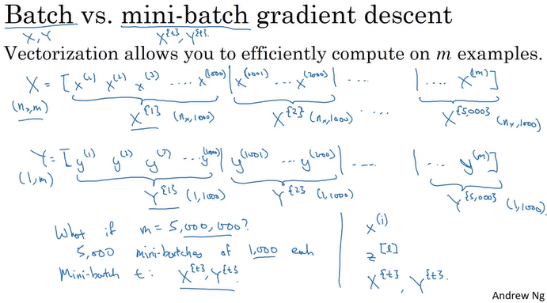
* Let's say that you split up your training set into smaller, little baby training sets and these baby training sets are called mini-batches. And let's say each of your baby training sets have just 1,000 examples each. So, you take X1 through X1,000 and you call that your first little baby training set, also call the mini-batch
* For 5 million examples-> 5000 minibatches of 1000 examples each

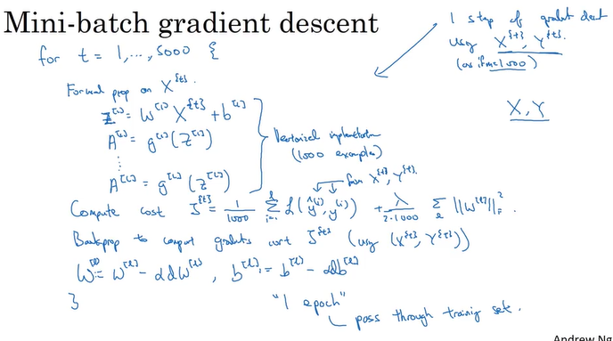

* Little training set size of M equals 1,000 rather than having an explicit for loop over all 1,000 examples, you would use vectorization to process all 1,000 examples sort of all at the same time.
* In the formula z= W*X + b you use x as 1000 examples rather than the entire training set(5million)
* It's just that this vectorized implementation processes 1,000 examples at a time rather than 5 million examples.

## epoch

* Single pass through the training set
* Whereas with batch gradient descent, a single pass through the training allows you to take only one gradient descent step.
* With mini-batch gradient descent, a single pass through the training set, that is one epoch, allows you to take 5,000 gradient descent steps. (5000 different mini batch processed simultaneously)
* When you have a lots of training set, mini-batch gradient descent runs much faster than batch gradient descent

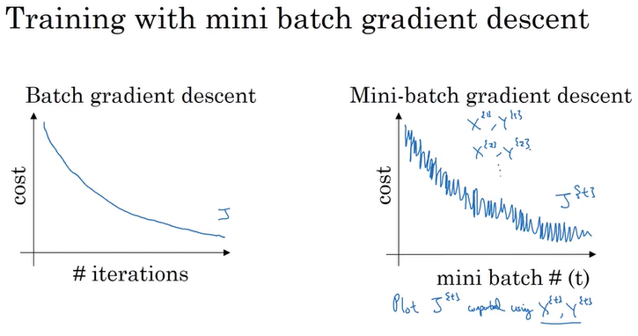

## Stochastic gradient descent

* ***With 1 training example m=1***
* ***On every iteration you're taking gradient descent with just a single strain example*** so most of the time you hit two at the global minimum. But sometimes you hit in the wrong direction if that one example happens to point you in a bad direction. So stochastic gradient descent can be extremely noisy.
* Loose speeding from vectorization

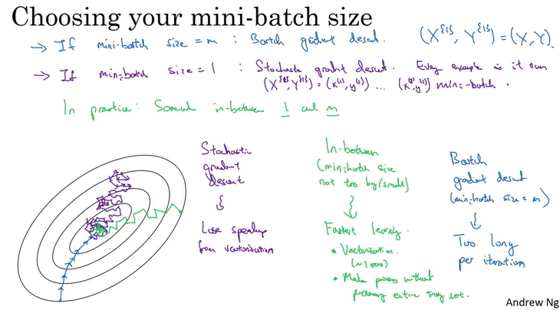

## Choosing mini batch size

If m<=2000 use batch gradient, otherwise typical mini batch size 64,128,256 etc.

## Optimization Algorithms

### Exponentially weighted averages

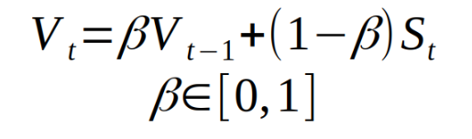

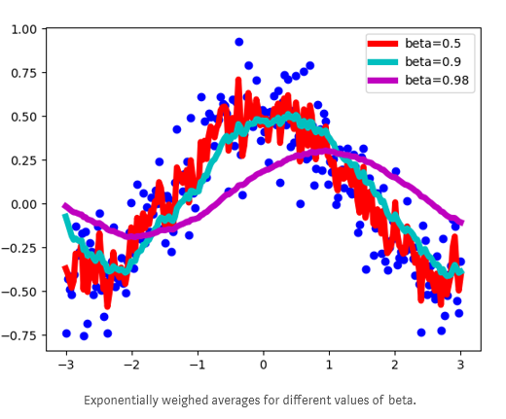

As you can see, with smaller numbers of beta, the new sequence turns out to be fluctuating a lot, because we’re averaging over smaller number of examples and therefore are ‘closer’ to the noisy data. With bigger values of beta, like beta=0.98, we get much smother curve, but it’s a little bit shifted to the right, because we average over larger number of example(around 50 for beta=0.98). Beta = 0.9 provides a good balance between these two extremes.

* Where you need to compute averages of a lot of variables. This is a very efficient way to do so both from computation and memory efficiency point of view
* exponentially weighted moving averages in statistics.

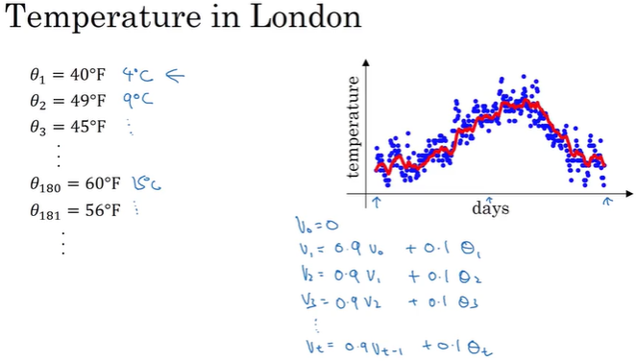

* V0, V1 .. Vt are the average of the days’ temperatures. 1st day’s average, 2nd days average etc.
* General formula is V on a given day is 0.9 times V from the previous day, plus 0.1 times the temperature of that day
* The red line is the average of days.
* Vt is approximately averaging over, something like one over one minus beta, day's temperature.

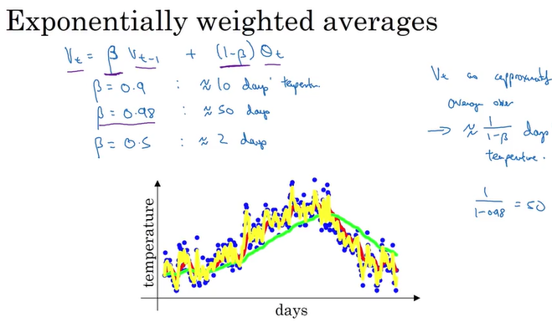

* Adapts more slowly when beta is so large (green line with bigger beta; yellow with lowest beta)
* We're going to call it exponentially weighted average for short and by varying this parameter or later we'll see such a hyper parameter if you're learning algorithm you can get slightly different effects and there will usually be some value in between that works best.

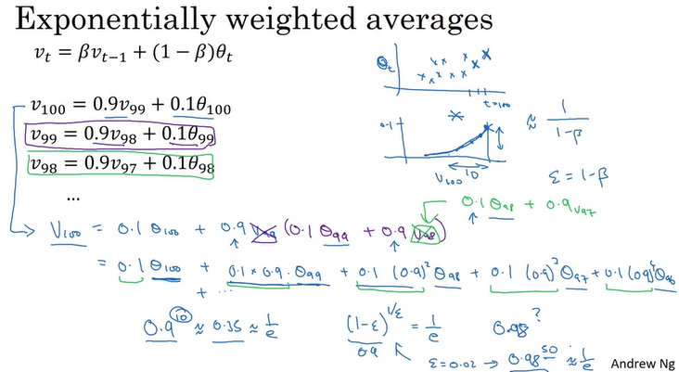

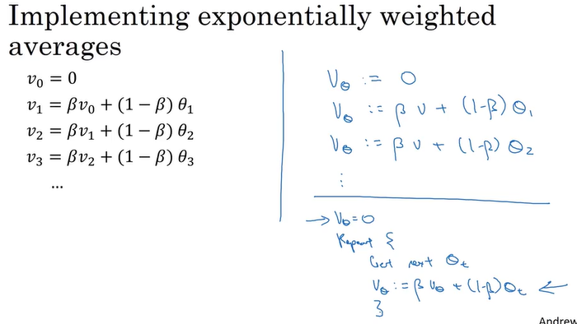

* So one of the advantages of this exponentially weighted average formula, is that it takes very little memory. You just need to keep just one row number in computer memory, and you keep on overwriting it with this formula based on the latest values that you got.
* The efficiency, it just takes up one line of code basically and just storage and memory for a single row number to compute this exponentially weighted average.
* On the other hand
  + You can explicitly sum over the last 10 days, the last 50 days temperature and just divide by 10 or divide by 50, that usually gives you a better estimate.
  + But the disadvantage of that, of explicitly keeping all the temperatures around and sum of the last 10 days is it requires more memory,

and it's just more complicated to implement and is computationally more expensive.

### Bias correction

Bias correction can make computation of the averages more accurately.

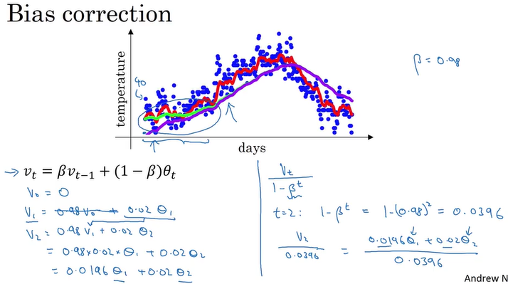

* Notice that the purple curve starts off really low.
* When t is large enough, the bias correction (1- 0.98) ^ t makes almost no difference. The purple line and the green line pretty much overlap. But during this initial phase of learning when you're still warming up your estimates when the bias correction can help you to obtain a better estimate of this temperature. And it is this bias correction that helps you go from the purple line to the green line.

### GD with Momentum

* There's an algorithm called momentum, or gradient descent with momentum that almost always works faster than the standard gradient descent algorithm.
* In one sentence, the basic idea is to compute an exponentially weighted average of your gradients, and then use that gradient to update your weights instead 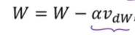

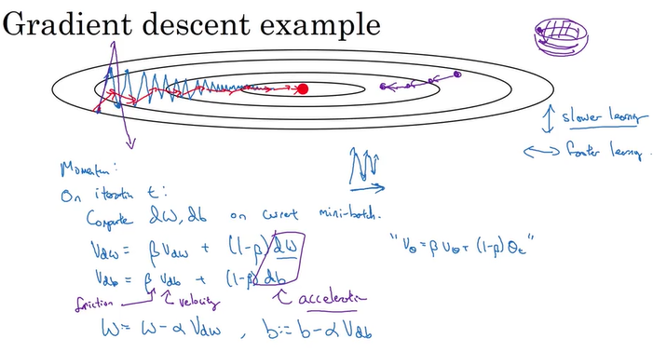

* This up and down oscillations slows down gradient descent and prevents you from using a much larger learning rate(the left hand side of the figure above oscillations to the minimum)
* If you use larger learning rate, it may diverge from minimum
* Slower learning vertically, not to face oscillations.
* We want it to aggressively move from left to right, toward that minimum, toward that red dot. So here's what you can do if you implement gradient descent with momentum.
  + On each iteration you would compute the usual derivatives dw, db
  + Then computing the Vdw as 
  + So it's computing a moving average of the derivatives for w you're getting.
  + And then you similarly compute vdb equals that plus 1 minus Beta times db.
  + And then you would update your weights using W gets updated as W minus the learning rate times, instead of updating it with dW, with the derivative, you update it with vdW(average dW)
* So what this does is smooth out the steps of gradient descent.
* If you average out these gradients, you find that the oscillations in the vertical direction will tend to average out to something closer to zero. So, in the vertical direction, where you want to slow things down, this will average out positive and negative numbers, so the average will be close to zero.
* just taking steps that are much smaller oscillations in the vertical direction, but are more directed to just moving quickly in the horizontal direction

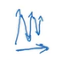

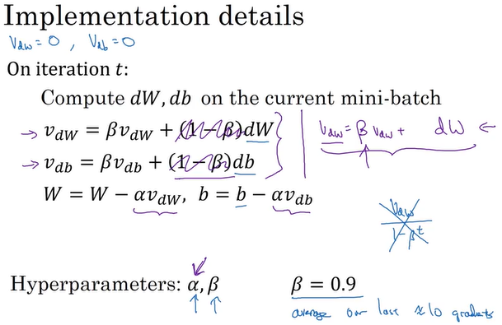

### RMSprop

Root mean square prop

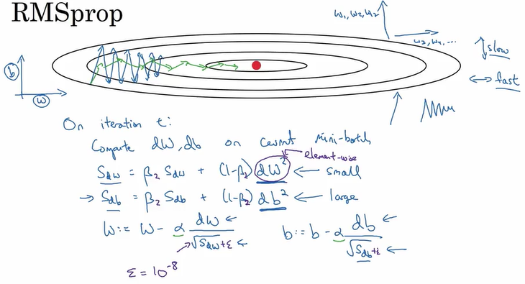

* We want w to go fast, in contrast b to go slow
* Epsilon used for the denominator not to be 0.

### Adam Optimization Algorithm

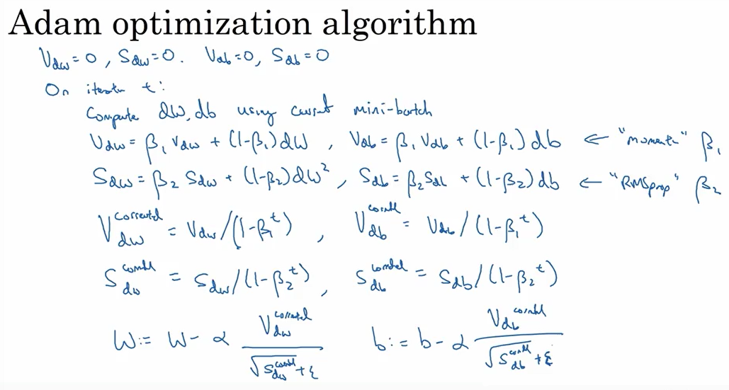

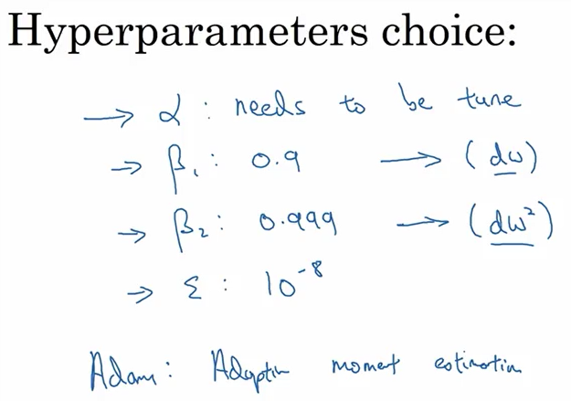

## Learning rate decay

* as you iterate, your steps will be a little bit noisy. And it will tend towards this minimum over here, but it won't exactly converge. But your algorithm might just end up wandering around, and never really converge, because you're using some fixed value for alpha.
* And there's just some noise in your different mini-batches. But if you were to slowly reduce your learning rate alpha, then during the initial phases, while your learning rate alpha is still large, you can still have relatively fast learning.
* But then as alpha gets smaller, your steps you take will be slower and smaller. And so you end up oscillating in a tighter region around this minimum, rather than wandering far away, even as training goes on and on.
* ***So the intuition behind slowly reducing alpha, is that maybe during the initial steps of learning, you could afford to take much bigger steps. But then as learning approaches converges, then having a slower learning rate allows you to take smaller steps***

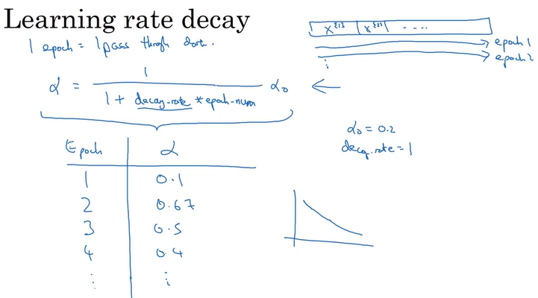

* As a function of your epoch number, your learning rate gradually decreases, right, according to this formula up on top

## Local Optima

* In the early days of deep learning, people used to worry a lot about the optimization algorithm getting stuck in bad local optima. But as this theory of deep learning has advanced, our understanding of local optima is also changing

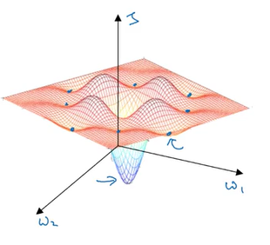

* It seems that in the picture there are lots of local optima that prevents the algorithm to go to the global minimum
* But this intuition isn't actually correct. It turns out if you create a neural network, most points of zero gradients are not local optima like points like this. Instead most points of zero gradient in a cost function are ***saddle*** points.

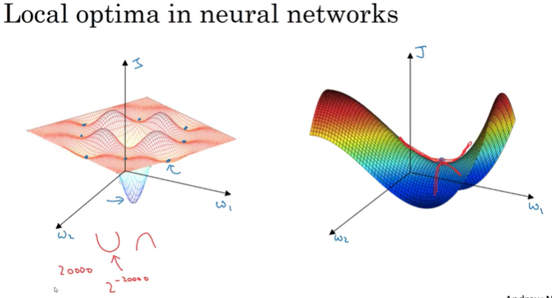

* And if you are in, say, a 20,000 dimensional space, then for it to be a local optima, all 20,000 directions need to look like this. And so the chance of that happening is maybe very small, maybe two to the minus 20,000.
* Instead you're much more likely to get some directions where the curve bends up like so, as well as some directions where the curve function is bending down rather than have them all bend upwards. ***So that's why in very high-dimensional spaces you're actually much more likely to run into a saddle point*** like that shown on the right, then the local optimum. (Because if you have 20,000 parameters, then J as your function over 20,000 dimensional vector)

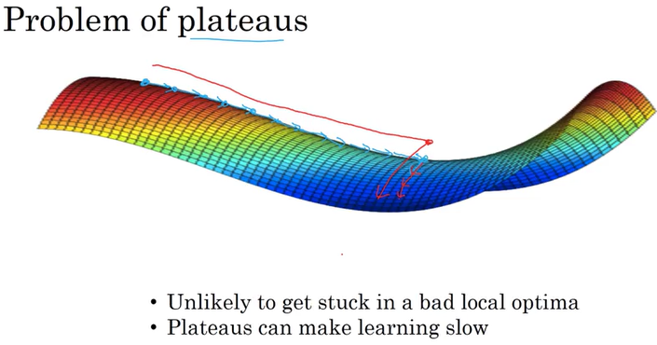

* Plateaus are a problem and you can actually make learning pretty slow. And this is where algorithms like momentum or RmsProp or Adam can really help your learning algorithm as well.

# W3

<https://nhannguyen95.github.io/coursera-deep-learning-course-2-week-3/#tuning-process>

## Tuning Process

* One of the painful things about training deepness is the sheer number of hyper parameters you have to deal with, ranging from the learning rate alpha to the momentum term beta, if using momentum, or the hyper parameters for the Adam Optimization Algorithm which are beta one, beta two, and epsilon.

### Hyperparameters

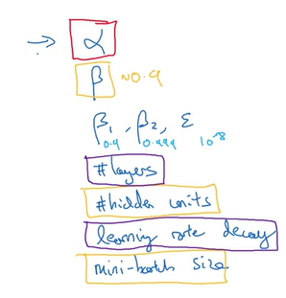 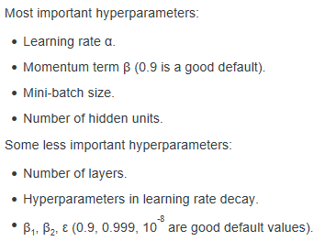

* Some hyperparameters, such as the learning rate, are more critical than others.
* If searching among a large number of hyperparameters, you should try **random values rather** than in a grid (referans çizgileri ağı)
* The reasons you shouldn’t use a grid is that **it’s difficult to know in advance which hyperparameters is the most important** one for your problem.
* For example, hyperparameter1 = learning rate α (important), hyperparameter2 = ε (hardly matter): you may train 25 models and only try out 5 values of α (because all ε values give the same answer).
* In practice, you might be searching over many more hyperparameters (instead of only 2).

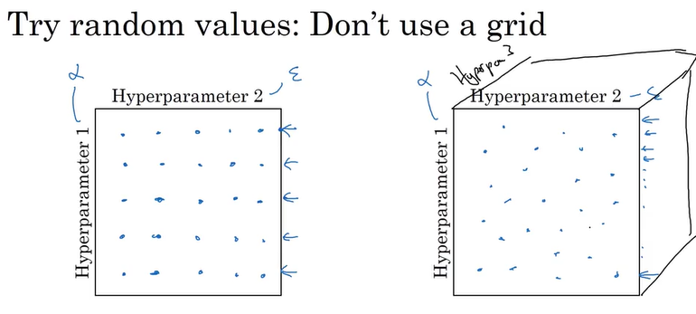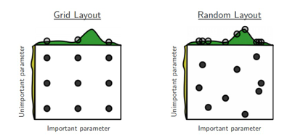

* In earlier generations of machine learning algorithms, if you had two hyper parameters, which I'm calling hyper parameter one and hyper parameter two here, it was common practice to sample the points in a grid like so and systematically explore these values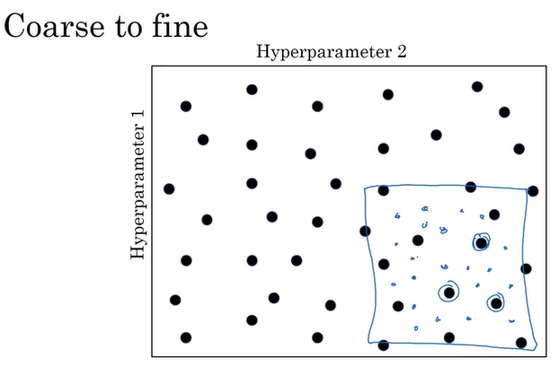
* So after doing a coarse sample of this entire square, that tells you to then focus on a smaller square. You can then sample more densely into smaller square.

## Using an appropriate scale to pick hyperparameters

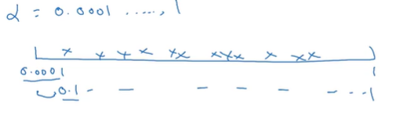

* Now if you draw the number line from 0.0001 to 1, and sample values uniformly at random over this number line. **Well about 90% of the values you sample would be between 0.1 and 1.** So you're using 90% of the resources to search between 0.1 and 1, and only 10% of the resources to search between 0.0001 and 0.1. So that doesn't seem right

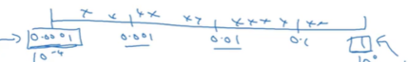

* Instead it seems more reasonable to search for **hyperparam on a log scale**.(10^2,10

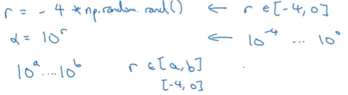

## Hyperparameter for momentum(Beta)

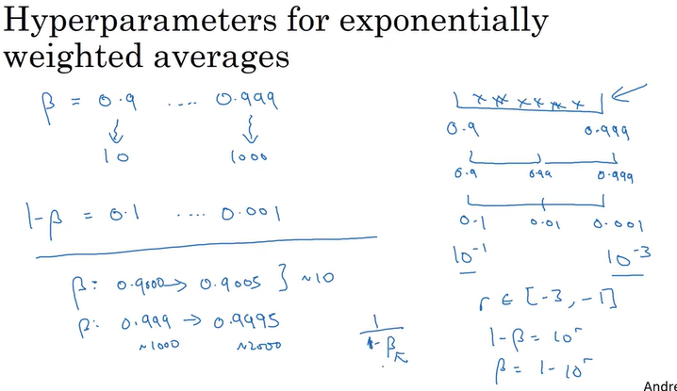

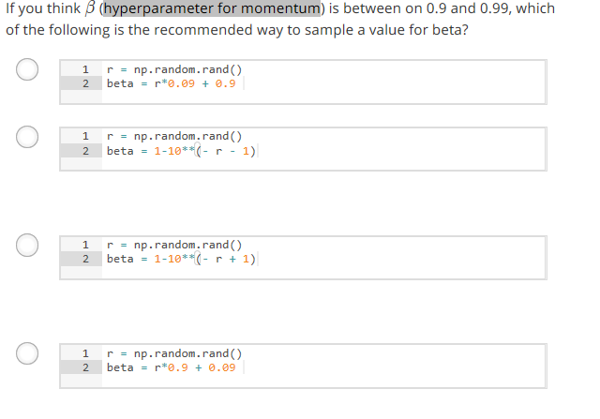

**Q: Why is it such a bad idea to sample in a linear scale?**

A: It is that, when beta is close to 1, the sensitivity of the results you get changes, even with very small changes to beta.

* So if beta goes from 0.9 to 0.9005, it's no big deal, this is hardly any change in your results.
* But if beta goes from 0.999 to 0.9995, this will have a huge impact on exactly what your algorithm is doing, right?
* In both of these cases, it's averaging over roughly 10 values. But here it's gone from an exponentially weighted average over about the last 1,000 examples, to now, the last 2,000 examples.
* **And it's because that formula we have, 1 / 1- beta,** this is very sensitive to small changes in beta, when beta is close to 1. So what this whole sampling process does, is it causes you to sample more densely in the region of when beta is close to 1.

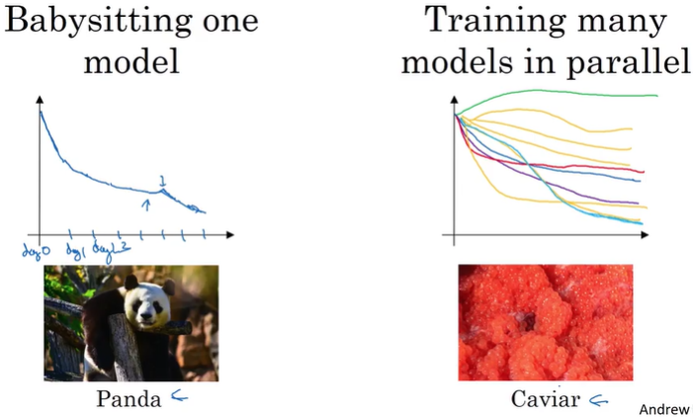

* **if you have maybe a huge data set but not a lot of computational resources**, not a lot of CPUs and GPUs, so you can basically afford to train only one model or a very small number of models at a time.
* In that case you might gradually babysit that model even as it's training. So, for example, on Day 0 you might initialize your parameter as random and then start training. And you gradually watch your learning curve, maybe the cost function J or your dataset error or something else, gradually decrease over the first day. Then at the end of day one, you might say, gee, looks it's learning quite well, I'm going to try increasing the learning rate a little bit and see how it does. And then maybe it does better. And then that's your Day 2 performance. And after two days you say, okay, it's still doing quite well. Maybe I'll fill the momentum term a bit or decrease the learning variable a bit now, and then you're now into Day 3.
* The other approach would be if you train many models in parallel. So you might have some setting of the hyperparameters and just let it run by itself ; and then at the same time you might start up a different model with a different setting of the hyperparameters.
* If you have enough computers to train a lot of models in parallel, then by all means take the caviar approach and try a lot of different hyperparameters and see what works. But in some application domains, I see this in some online advertising settings as well as in some computer vision applications, where there's just so much data and the models you want to train are so big that it's difficult to train a lot of models at the same time.

## Normalizing activations in a network

### Batch normalization

* <https://wiseodd.github.io/techblog/2016/07/04/batchnorm/>
* One difficult thing about training a neural net **is to choose the initial weights**. BatchNorm promises the remedy: **it makes the network less dependent to the initialization strategy.** Another key points are that it enables us to use higher learning rate. They even go further to state that BatchNorm could reduce the dependency on Dropout.
* The main idea of BatchNorm is this: for the current minibatch while training, in each hidden layer, **we normalize the activations so that its distribution is Standard Normal** (zero mean and one standard deviation). Then, we apply a linear transform to it with learned parameters so that the network could learn what kind of distribution is the best for the layer’s activations.
* This in turn will make the gradient flows better as activations saturation is not a problem anymore. Recall that activations saturation kills neurons in case of ReLU and makes gradient vanish or explode in case of sigmoid.

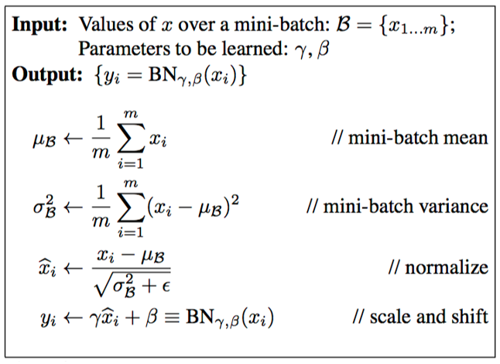

* Makes your hyperparameter search problem much easier, makes your neural network much more robust.
* Normalizing the input features can speed up learnings in compute the means, subtract off the means from your training sets. Compute the variances.

**!!**

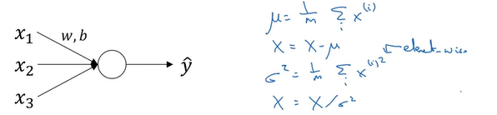

* Now, how about a deeper model?

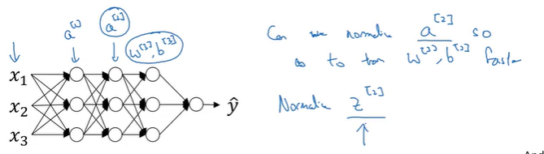

* You have not just input features x, but in this layer you have activations a1, in this layer, you have activations a2 and so on. So if you want to train the parameters, say w3, b3, then

wouldn't it be nice if you can normalize the mean and variance of a2 to make the training of w3, b3 more efficient?

* Normalizing x1, x2, x3 maybe helps you train w and b more efficiently.
* **We'll actually normalize the values of not a2 but z2.**

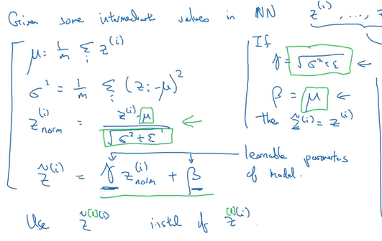

* **What batch norm does is it applies that normalization process not just to the input layer, but to the values even deep in some hidden layer in the neural network.**
* But one difference between the training input and these hidden unit values is you might not want your hidden unit values be forced to have mean 0 and variance 1

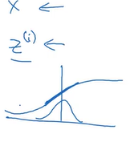

* If you have a sigmoid activation function, you don't want your values to always be clustered on a little variance.
* In order to better take advantage of the nonlinearity of the sigmoid function rather than have all your values be in just this linear regime.

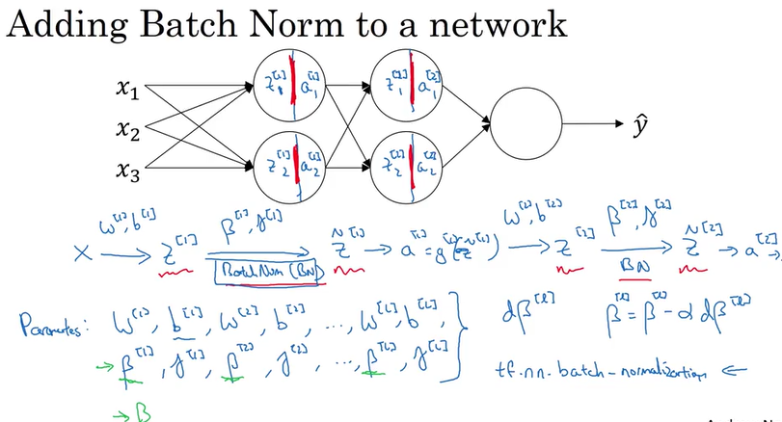

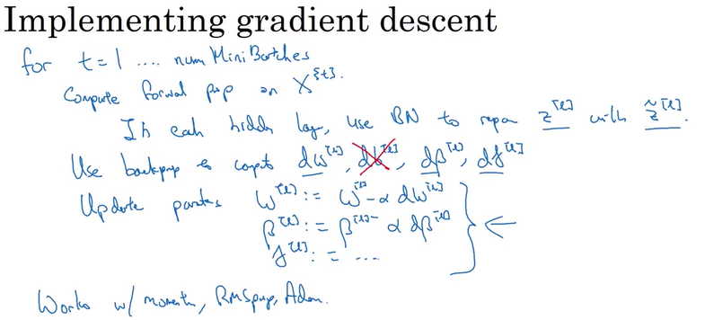

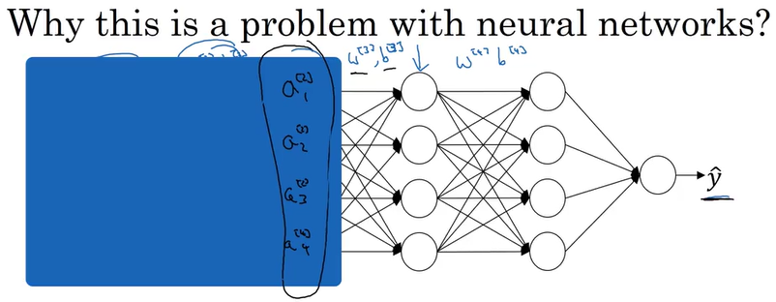

* So from the perspective of the third hidden layer, these hidden unit values are changing all the time, and so it's suffering from the problem of covariate shift
* So what batch norm does, is it reduces the amount that the distribution of these hidden unit values shifts around.

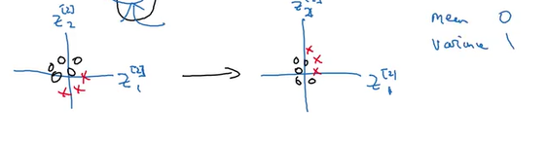

* What **batch norm ensures is that no matter how it changes, the mean and variance of Z_2_1 and Z_2_2 will remain the same.**
* So even if the exact values of Z_2_1 and Z_2_2 change, their mean and variance will at least stay same mean zero and variance one but whatever value is governed by beta two and gamma two
* But what this does is, it limits the amount to which updating the parameters in the earlier layers can affect the distribution of values that the third layer now sees and therefore has to learn on.
* **And so, batch norm reduces the problem of the input values changing**, it really causes **these values to become more stable**, so that the later layers of the neural network has more firm ground to stand on
* if you use a mini-batch size of, say, 512 instead of 64, by using a larger mini-batch size, you're reducing this noise and therefore also **reducing this regularization effect**

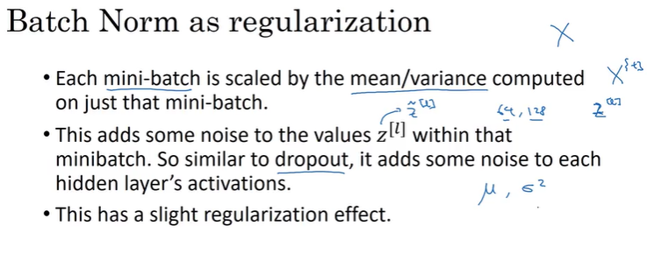

* Because by adding noise to the hidden units, it's forcing the downstream hidden units not to rely **too much on any one hidden unit**. And so similar to dropout, it adds noise to the hidden layers and therefore has a very slight regularization effect.

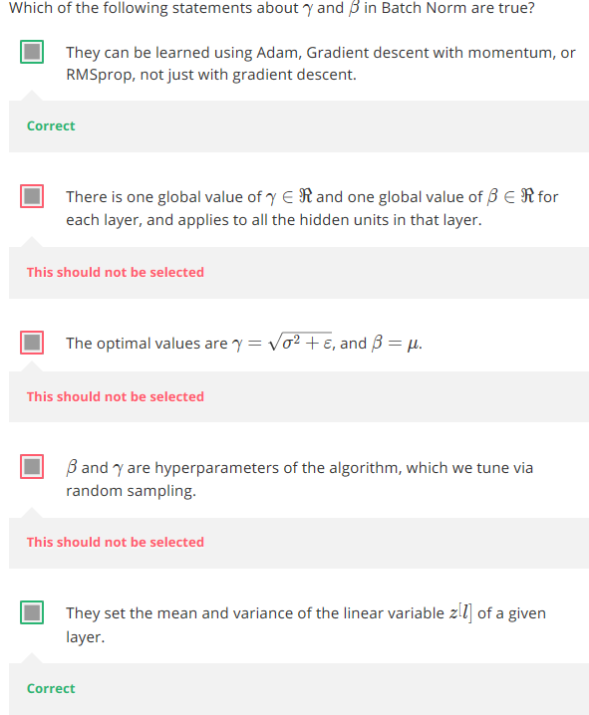

### Batch norm at test time

* Batch norm processes your data one mini batch at a time, but the test time you might need to process the examples one at a time.
* After training a neural network with Batch Norm, at test time, to evaluate the neural network on a new example you should:

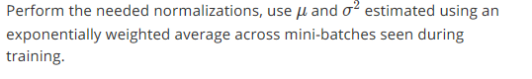

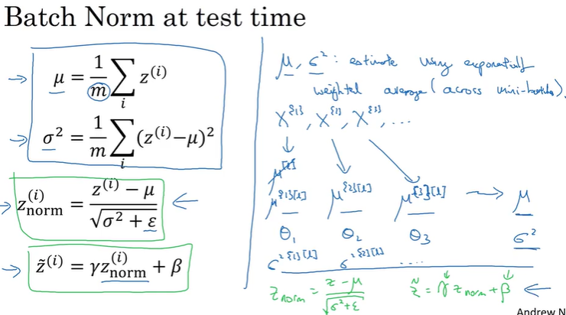

* M to denote the number of examples in the mini batch not in the whole training set.
* So, notice that mu and sigma squared which you need for this scaling calculation are computed on the entire mini batch. **But the test time you might not have a mini batch of 6428 or 2056 examples to process at the same time**. So, you need some different way of coming up with mu and sigma squared. And if you have just one example, taking the mean and variance of that one example, doesn't make sense.
* So what's actually done?
  + **What you do is estimate this using a exponentially weighted average where the average is across the mini batches**
  + Let's pick some layer L and let's say you're going through mini batches X1, X2 together with the corresponding values of Y and so on. So, when training on X1 for that layer L, you get some mu L. And in fact, I'm going to write this as mu for the first mini batch and that layer. And then when you train on the second mini batch for that layer and that mini batch, you end up with some second value of mu. And then for the fourth mini batch in this hidden layer, you end up with some third value for mu

## Softmax Regression

* What if we have **multiple possible classes?** There's a generalization of logistic regression called Softmax regression

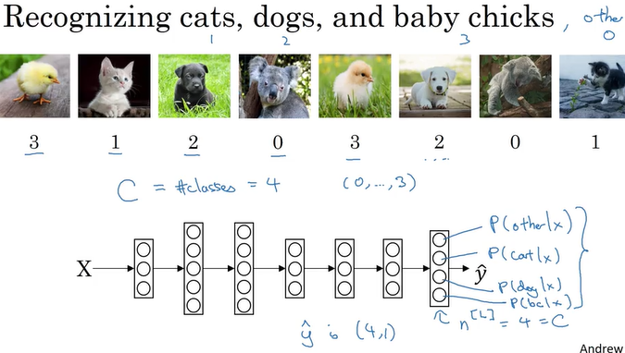

### Softmax Layer

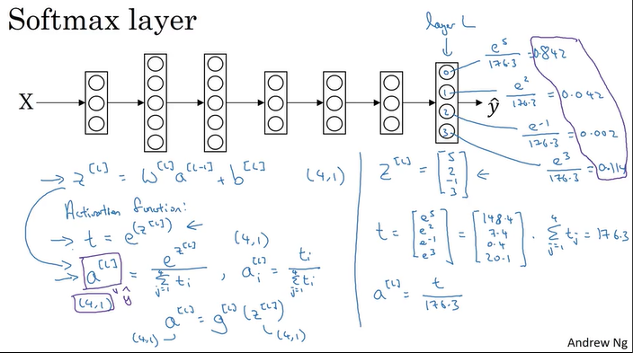

* So previously, our activation functions used to take in a single row value input.
* The unusual thing about the Softmax activation function is, because it needs to normalized across the different possible outputs, and needs to take a vector **and puts in outputs of vector.**

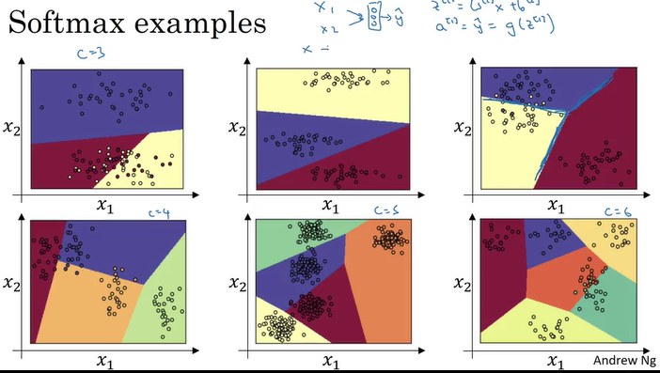

### Training a softmax classifier

Hardmax is putting 1 to vector element with max num; and zeros to others

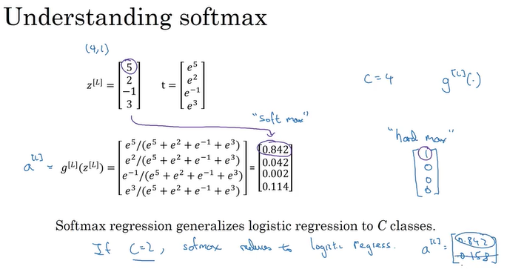

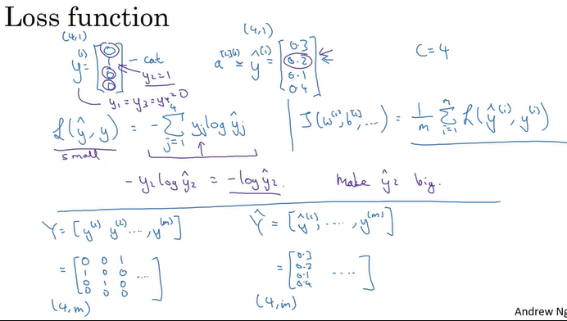

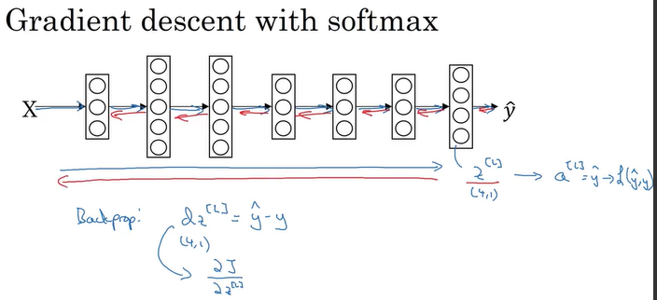

## DL Framework

To implement complex models such as convolutional NN or recurring NN ; it is not practical to implement everything yourself from scratch. Fortunately, there are now many good deep learning software frameworks that can help you implement these models.

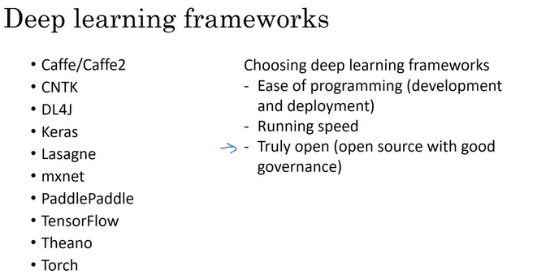

## Tensorflow

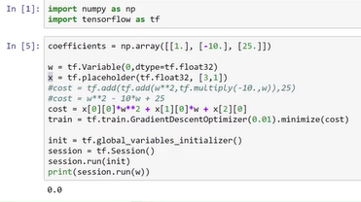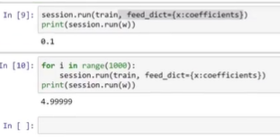

Programming frameworks like Tensor Flow have already **built-in the necessary backward functions**. Which is why by using the built-in functions to compute the forward function, it can automatically do the backward functions as well to implement back propagation through even very complicated functions and compute derivatives for you. So that's why you don't need to explicitly implement back prop

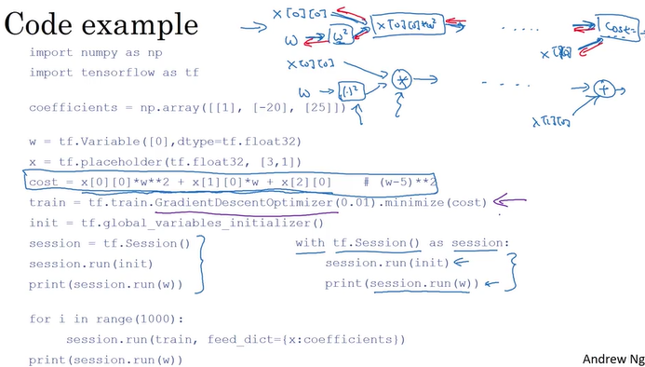

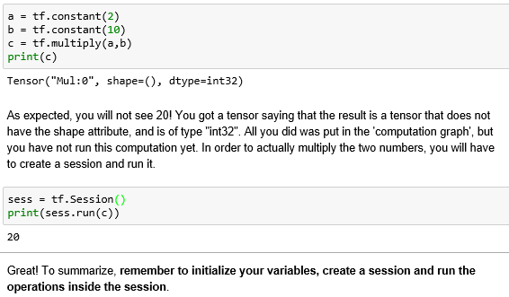

### Tf.constant

X = tf.constant(np.random.randn(3,1), name = "X")

### Tf.placeholder

x = tf.placeholder(tf.int64, name = 'x')

When you first defined x you did not have to specify a value for it. A placeholder is simply a variable that you will assign data to only later, when running the session. We say that you **feed data** to these placeholders when running the session.